

**Chittagong University of Engineering and Technology(CUET)**

**Course Name:** Software Development with Java (Sessional)

**Course Code:** CSE-200

**Project Name:** ATemperature Converter for Celsius, Fahrenheit and Kelvin scale & Grade Calculator

**Supervised By:**

Animesh Chandra Roy [Md. Mynul Hasan](https://www.cuet.ac.bd/members/524)

Assistant Professor Lecturer

Dept. of CSE, CUET Dept. of CSE, CUET

**Presented by:**

Md.Ashik Billah Fahim ID:1804036

Md.Al-Amin Khan ID:1804043

Jawad Al Shahariar ID:1804045

Suzab-Ud-Doula ID:1804065

Section: A

Level-2 Term-2

**REMARKS**

**Contents:**

Introduction

Application

Motivation

Flow Chart

Function Description

Project Output

Conclusion

**Introduction:**

A converter can convert units from one scale to another. The most popular scales for measuring temperature are Celsius, Fahrenheit and Kelvin.

The equation for converting Celsius, Fahrenheit and Kelvin is:

C/5=(F-32)/9=K-273/5

Temperature is measured using a thermometer. While Kelvin (K) is the SI unit of temperature, people generally use Centigrade or Celsius (°C) and Fahrenheit (°F) to measure temperature. A temperature converter helps in the conversion of the measurement units of the temperature recorded in a particular unit. Temperature expresses the degree of heat or cold of a solid, liquid, or gas. Temperature is measured using a thermometer.

**Application:**

**Real world usage:**We use temperature converter to find the different readings of a given temperature on different unit measuring scales.  
Different device or country use its preferred unit to measure.  
By using a converter a person can read temperature in his preferred scale. Measured temperature can be converted easily. Measured heat, specific heat can be converted into different scale. Temperature converter can be used in thermodynamics. Some other real life use is the calorimeter. Calorimeter is used in calorimeter, it is the process of measuring the heat of chemical reactions. Temperature gained from a calorimeter can be easily converted using a converter.

**Virtual world usage:**For virtual use purposes a converter can be created using java swing to solve numerous temperature converting problems. A simple converting program can help in this converting.  
Various software use temperature measuring to show stats of computers or mobiles while running other applications, to view in different temperature scales we can use a temperature converter.

**Motivation for this project:**

Considering the real and virtual life usage of temperature we selected this project. Using Java swing we easily created a converter. Temperature is measured in 3 scales. For general people it may prove to be difficult to use the equation to convert these scales as per needs. To do this with a simple click we implemented a converter. This is a prime reason for choosing this project.

**Flow chart:**

Finally presenting the full project

Creating the UI for temperature converter

Programming the clear and cancel button for the converter

|  |
| --- |
| Programming the convert button for the converter |

Finally presenting the full project

**Function Description:**

We used Java swing to creat the converter. For the UI components we used swing containers and swing control. For IDE we used NetBeans.  
The functions we used are listed below:

**Javax.swing.jFrame:**

jframe is class type of container. It works like the main window where the swing containers and controls are added.

**Javax.swing.JPanel:**

Jpanel is a generic lightweight container. Jpanel is used here to enrich the UI. The label is hence used on JPanel.

**Javax.swing.JLabel:**

Label is used to name the converter here. Here it is a temperature converter. So it is named using label.

**Javax.Swing.JComboBox:**

Two combobox is used here for the converter. As for the model that combo box uses to get data to display we named Celsius, Fahrenheit and Kelvin.

**Javax.swing.JTextField:**JTextField is used to take input and show output. Here we have two JTextField. One textfield is editable and other is non editable. The editable textfield is for taking input. The non-editable textfield is for showing output.  
**Javax.swing.JButton:**We used three buttons here. Clear button, Exit button and Convert button. The clear button is used to clear all textfields. The exit button is used to exit the program. Finally the convert button is used to convert temperature.

**Action Performed:  
  
Exit Button:**



**Clear Button:**



**Convert Button:**

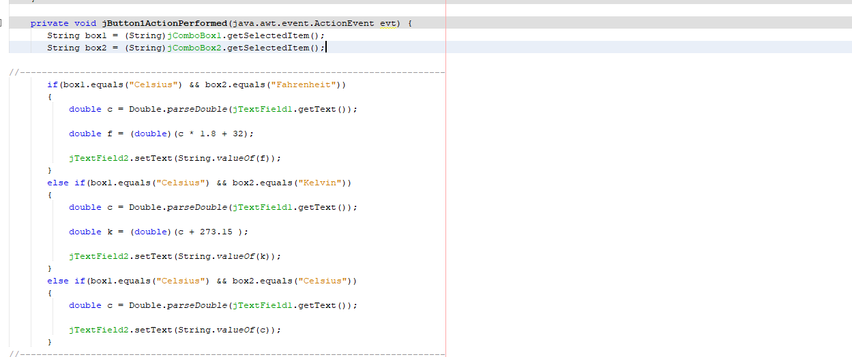

**Project output:**

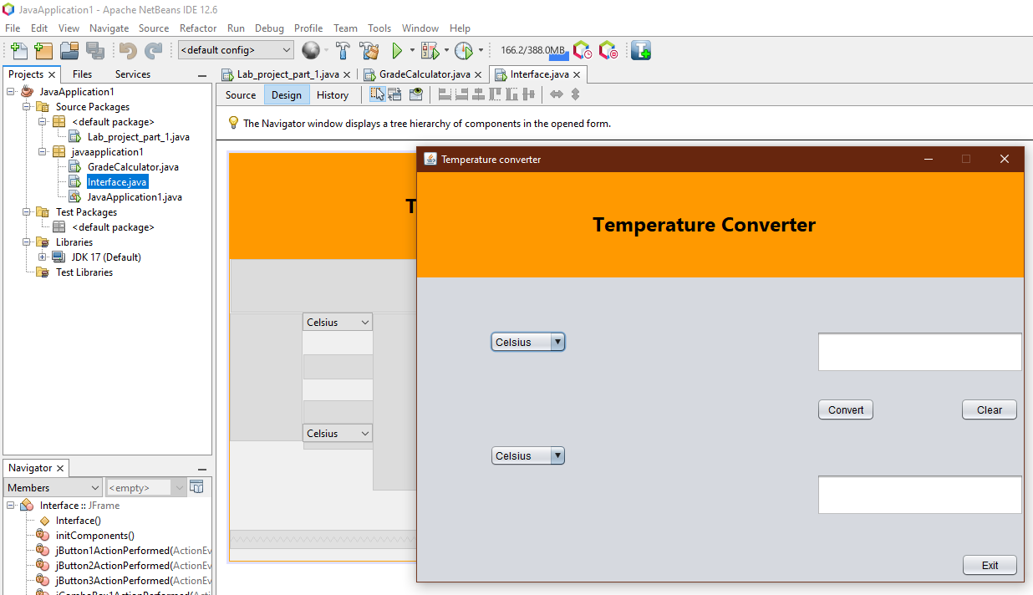

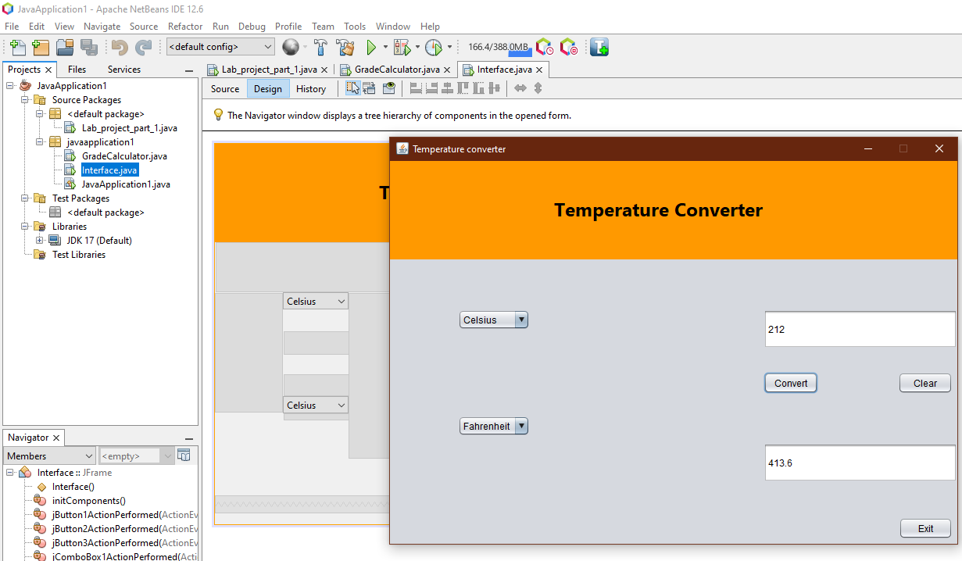

**Project Name:**  
A grade calculator to calculate a students total marks, percentage & grade.

**Introduction:**

A grade calculator can calculate the total marks of a student by adding all the subjects marks. Then it can calculate the total percentage of marks by dividing the sum with the number of subjects. Finally for calculating the grade of the students we set a conditions for calculating the grade with the help of percentage of marks of a student.

**Applications:**

While publishing a students grades a grade calculator is necessary. It can help to calculate a students total number, percentage of number and grade of a student.

It will help in academic result publication.

**Motivation:**

A grade calculator can be of use to a student. Since it can calculate a students total marks, percentage and grade of the total exam we selected this project.

**Flow Chart:**

Creating the UI for the calculator using Java swing

Creating the UI for the calculator using Java swing

Programming the clear and exit button

Creating the UI for the calculator using Java swing

Creating the UI for the calculator using Java swing

**Function Description:**  
We used Java swing to creat the grade calculator. we used Jframe form to do so. For the UI components we used swing containers and swing control. For IDE we used NetBeans.  
The functions we used are listed below:

**Javax.swing.jFrame:**

JFrame is class type of container. It works like the main window where the swing containers and controls are added.

**Javax.swing.JPanel:**

The panel is a generic lightweight container. The panel is used here to enrich the UI. The label is hence used on JPanel.

**Java.swing.JLabel:**

The label is used to name the calculator here. Here it is a grade calculator. So it is named using a label.

**Javax.swing.JTextField:**

Here in our project, we have nine text fields. The first text field is for the user’s name. The next five text field is for taking input for subjects. Then the next three text fields are total number, number percentage, and grade.

**Javax.swing.JButton:**  
In our project, we have five buttons. The exit button is for the program to exit. The clear button is for the text fields to set empty strings. We have a button to calculate the total number of a student. A Button to calculate the percentage. Then a button to calculate the grade of a student.

**Button Action Perform:  
Exit Button:**



**Clear Button:**

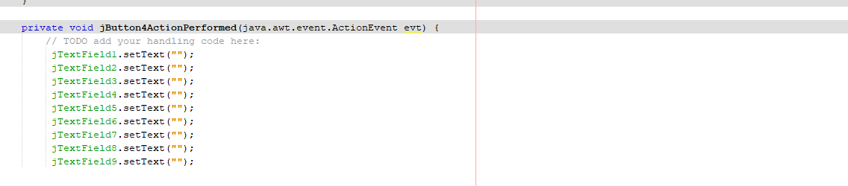

**Total Button:**

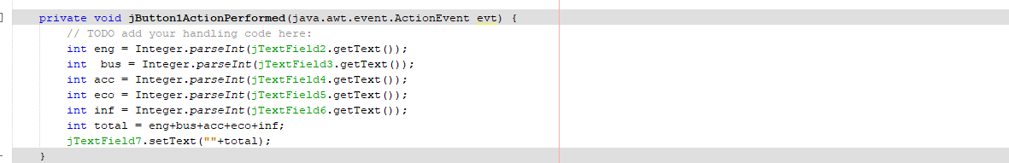

**Percentage Button:**



**Grade Button:**

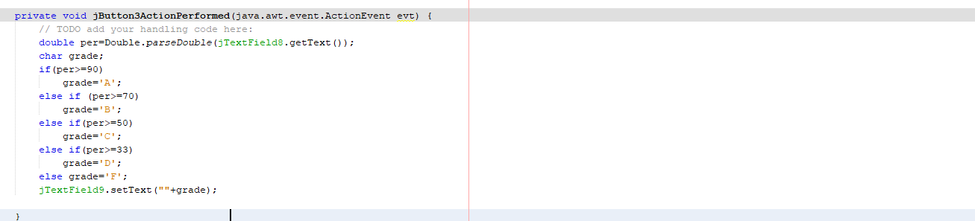

**Project Output:**

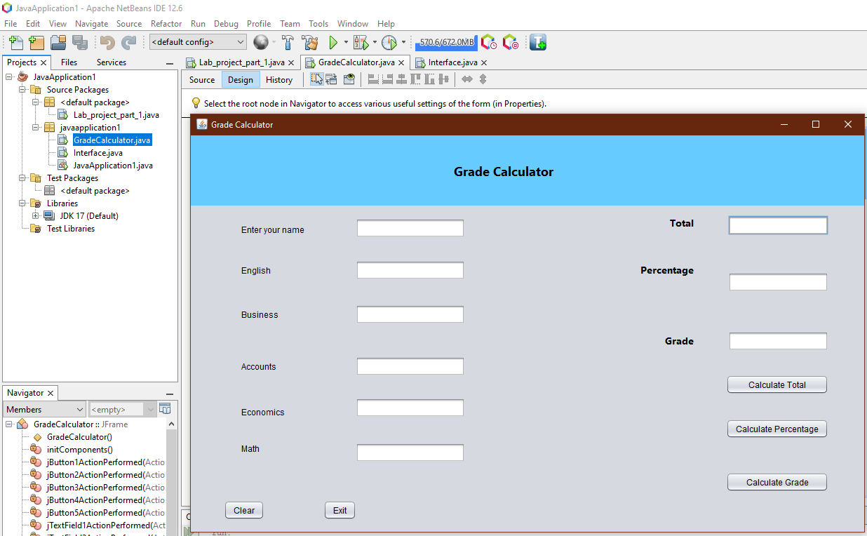

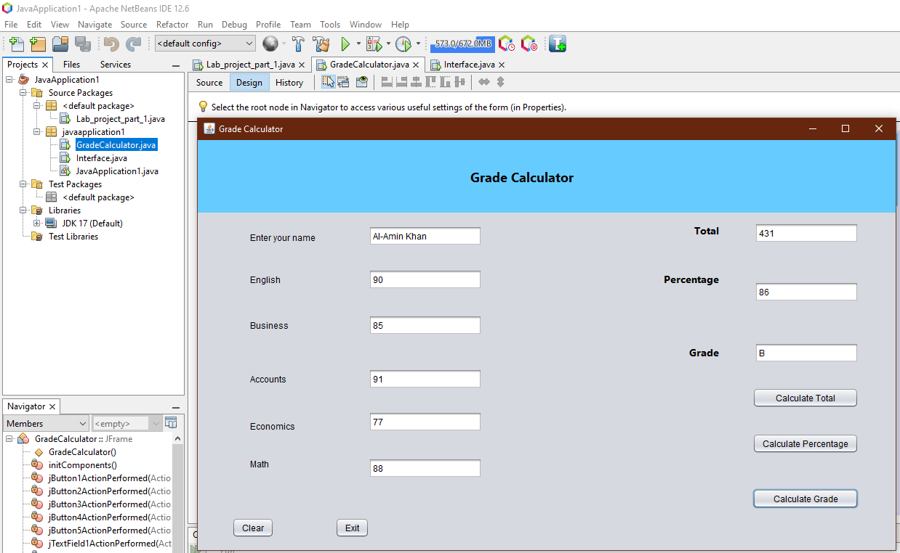

**Conclusion:**  
In this project, we created a temperature converter and a grade calculator using Java Swing.  
We used swing containers and controls to create the UI for both projects. We programmed the JButton events as actions for both the converter and grade calculator. In our converter, we can convert in three different scales. For the grade calculator, we can measure a student’s total number, number percentage, and grade for five subjects. Thus we completed both projects successfully without any error.